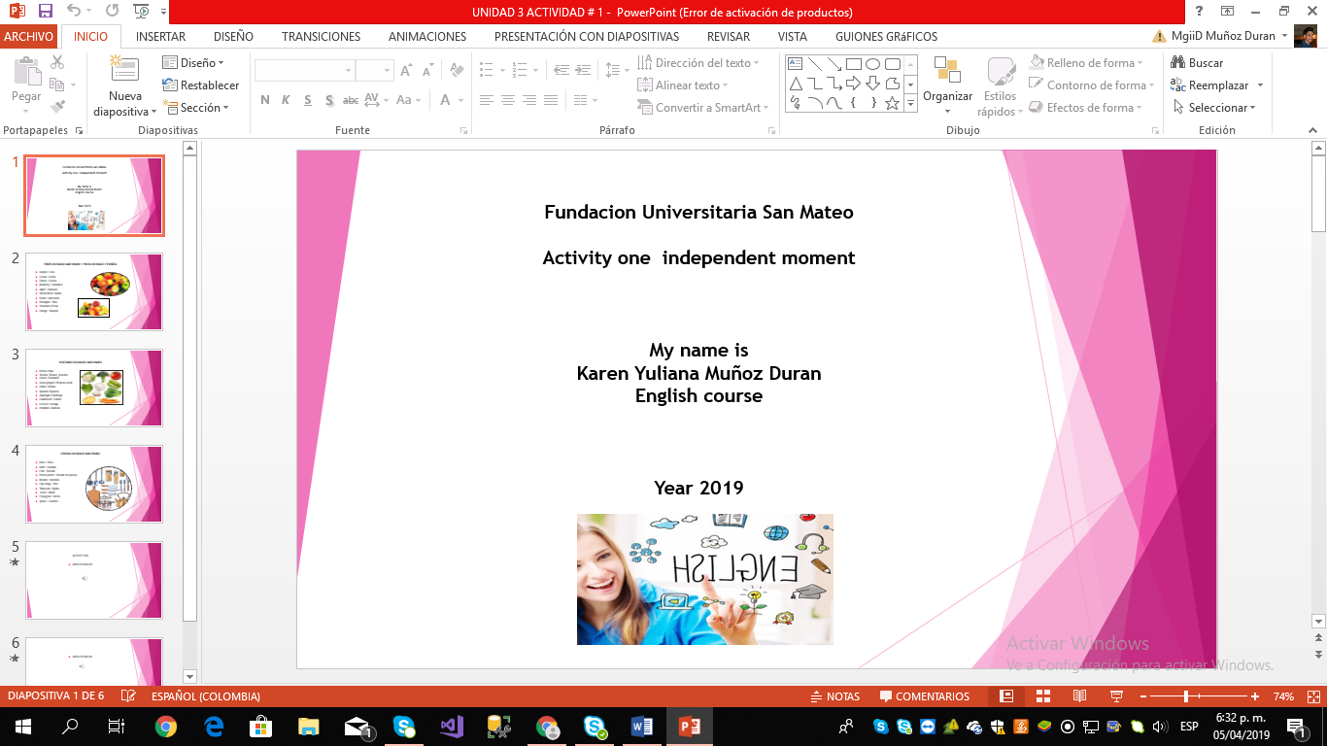

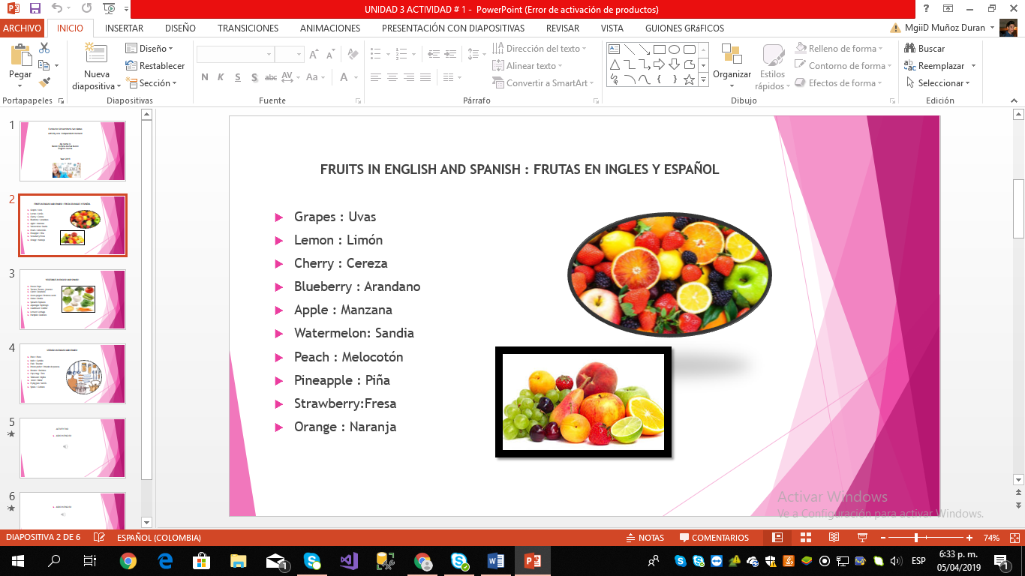

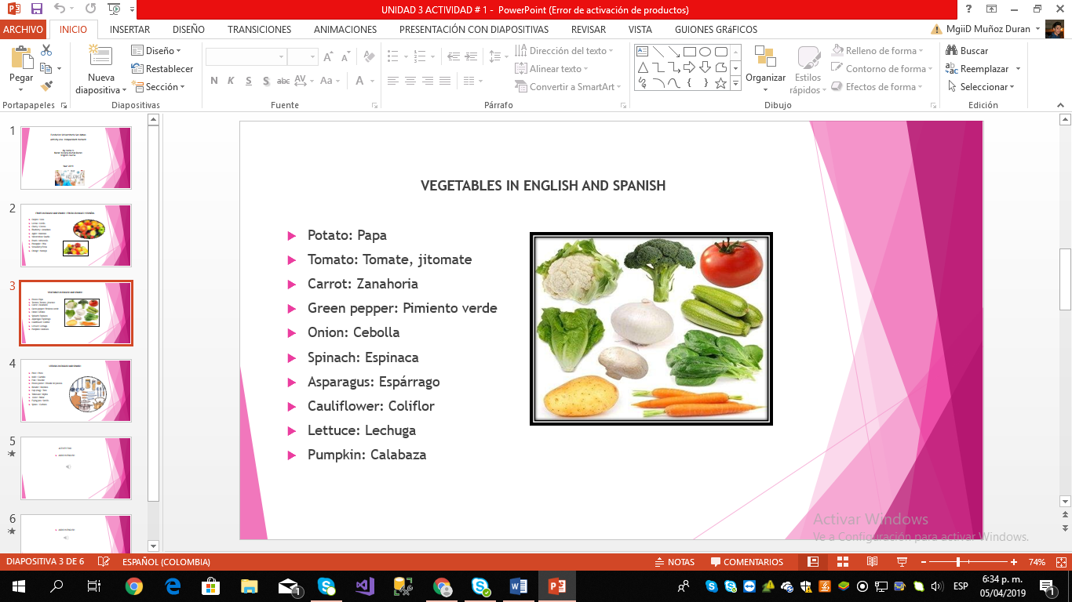

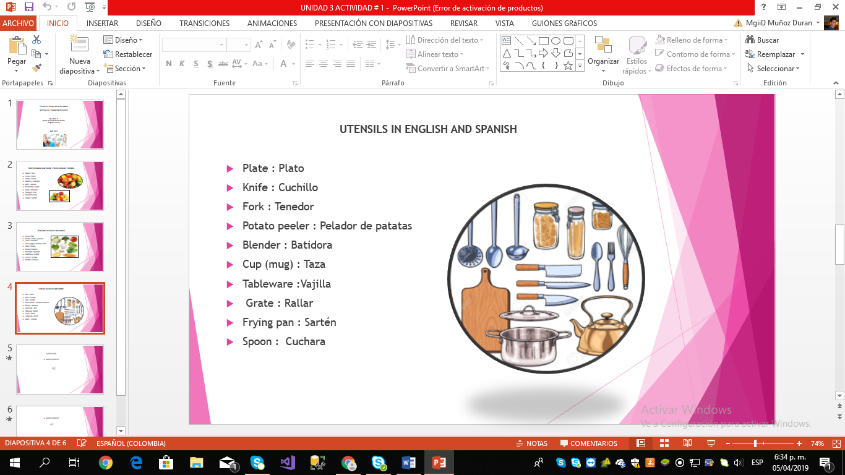

ACTIVITY TWO

AUDIO IN ENGLISH

<https://drive.google.com/file/d/1LqHbdbLW02y8XRtrByfsiE2w6j4Mfaw3/view?usp=sharing>

ACTIVITY THREE

AUDIO IN ENGLISH

<https://drive.google.com/file/d/1U-2qFMrz1A1jiAFlC0Yl4P6sou_h2KsX/view?usp=sharing>